**Hackathon Project Phases Template** that ensures students can complete it efficiently while covering all six phases. The template is structured to capture essential information without being time-consuming.

**Hackathon Project Phases Template**

**Project Title:**

Gesture-Based Human-computer interaction.

**Team Name:**

GESTURE GENIUS

**Team Members:**

* Nikhitha Lade
* A.Shiva sai
* J.Reethu

**Phase-1: Brainstorming & Ideation**

**Objective:**

1.Gesture-Based Human-Computer Interaction System using OpenCV, MediaPipe and Palm's text-bison-001

2.By not using any mouse countrling the screen

**Key Points:**

* **Problem Statement:** Interaction Problems,Technical Probams,Applicatio-Specific Problems,Accessibility Problems.

**. Proposed Solution:** System Architecture,System Components,System Workflow,Advantages,Limitations,Future Enhancements

* **Target Users:** Primary Target Users,Secondary Target Users,Potential Target Users.
* **Expected Outcome:** (What Improved Accessibility,Enhanced user Experience,Increased Efficiency,Expanded Application Support,Advanced Gesture Recognition.

**Phase-2: Requirement Analysis**

**Objective:**

**• Real-time gesture recognition and feedback.**

* Define technical and functional requirements.

**Key Points:**

* **Technical Requirements:**
* 1. Hardware: Webcam or camera module for capturing video feed.
* 2. Software: OpenCV for computer vision and image processing
* 3. Algorithmic Requirements: Hand detection and tracking algorithm using MediaPipe
* 4. Performance Requirements: Real-time gesture recognition and feedback.
* **Functional Requirements:** (1. Gesture Recognition: The system should be able to recognize and classify hand gestures in real-time.
* 2. Hand Tracking: The system should be able to track the user's hand movements and detect gestures.
* 3. User Interface: The system should provide a user-friendly interface that displays visual feedback and guidance for users.

**Constraints & Challenges:**  • The user has a basic understanding of hand gestures and computer interaction.

• The system will be used in a controlled environment with minimal distractions.

**Phase-3: Project Design**

**Objective:**

* Create the architecture and user flow.

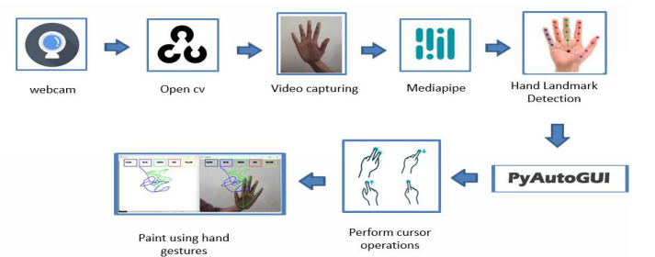

**Key Points:**

* **System Architecture Diagram:** Data capture,Preprocessing,Hand detection and tracing,Gesture recognition,Text description,Action execution,User interface.
* **User Flow:** The system starts, initializing the webcam and loading the necessary models and libraries (OpenCV, MediaPipe, text-bison-001)
* The user positions themselves in front of the camera.
* Each frame from the video feed is processed using OpenCV to enhance the image
* MediaPipe detects the user's hand(s) in the processed video frames.
* **UI/UX Considerations:**

1. User Interface (UI) Considerations

* a. Clean and Minimalistic Design
* b. Real-time Gesture Visualization
* c. Responsive Design
* 2. User Experience (UX) Considerations
* a. Natural and Intuitive Gesture
* b. Feedback & Confirmation Mechanisms
* c. Error Handling & Adaptability

**Phase-4: Project Planning (Agile Methodologies)**

**objective:**

Break down the tasks for gesture-Based Hman-computer

PHASE TASK DESCRIPTION TOOLS ESTIMATED TIME

1.Research Define project Outline goals & Docs,Research 1-Day

scope feature papers

2.Gesture Detect Setup openCV Implement basic openCV, (9-hours)

ion module &media pipe hand tracking Media Pipe

3.NLP Processing Integr ate Palm's Connect APL for palm APL, (6 hours)

model text python

**Key Points:**

* **Sprint Planning:** (Divide work into tasks for each team member)
* **Task Allocation:** (Who will do what?)
* **Timeline & Milestones:** (Set short deadlines for each task)

**Phase-5: Project development**

**Objective:**

* Code the project and integrate components.

**Key Points:**

* **Technology Stack Used:**
* 1.programming Languages
* 2.Computer Vision&Machine Learning
* 3.Web Development&API
* 4.Deployment&Cloud Services
* 5.Database
* **Development Process:**
* 1.Planning&Requirement Analysis
* 2.Technology Selection &Architeture Design
* 3.System Implementation&Development
* **Challenges & Fixes:**

1.Gesture Recognition Accuracy Issues

2.Lighting & Background Interference

3.Latency & Performance Issues

**Phase-6: Functional & Performance Testing**

**Objective:**

UT-01 Hand DEtect ion Place hand in front Hand landm arks are detected pass

of the camera and displayed

UT-02 Gestuer Recognition perform a predefined gesture Gesture is recognized pass

and labeled correctly

UT-03 Low-Light conditions perform gestures in dimlighting system adjusts and partial pass

recognizes gestures

correctly

**Final Submission**

* **Project Report Based on the templates**
* **Demo Video (3-5 Minutes)**
* **GitHub/Code Repository Link**
* **Presentation**